Logging using SLF4J

Exercise 1: Logging Error Messages and Warning Levels
Task: Write a Java application that demonstrates logging error messages and warning levels using SLF4J.

Step-by-Step Solution:
- Add SLF4J and Logback dependencies to your `pom.xml` file:
<dependency>
<groupId>org.slf4j</groupId>
<artifactId>slf4j-api</artifactId>
<version>1.7.30</version>
</dependency>
<dependency>
<groupId>ch.qos.logback</groupId>
<artifactId>logback-classic</artifactId>
<version>1.2.3</version>
</dependency>
- Create a Java class that uses SLF4J for logging:
import org.slf4j.Logger;
import org.slf4j.LoggerFactory;

public class LoggingExample {
private static final Logger logger = LoggerFactory.getLogger(LoggingExample.class);

public static void main(String[] args) { logger.error("This is an error message"); logger.warn("This is a warning message");
}
}
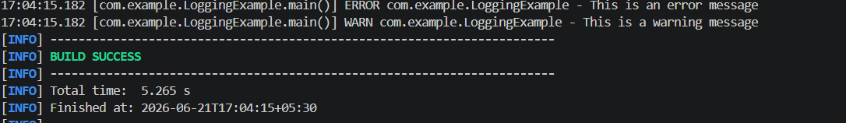

Exercise 2: Parameterized Logging
Task: Write a Java application that demonstrates parameterized logging using SLF4J.

Step-by-Step Solution:
- Add SLF4J and Logback dependencies to your `pom.xml` file:

<dependency>
<groupId>org.slf4j</groupId>
<artifactId>slf4j-api</artifactId>
<version>1.7.30</version>
</dependency>
<dependency>
<groupId>ch.qos.logback</groupId>
<artifactId>logback-classic</artifactId>
<version>1.2.3</version>
</dependency>
- Create a Java class that uses SLF4J for parameterized logging:
Write code for this.

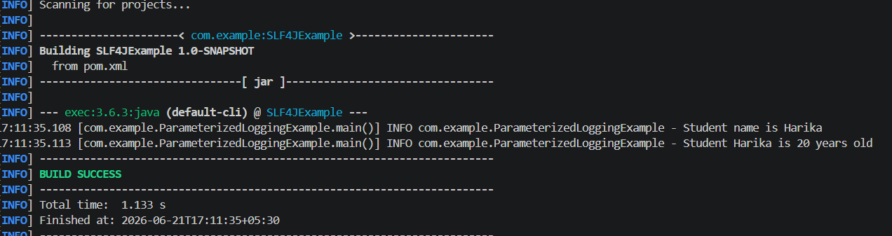

Exercise 3: Using Different Appenders
Task: Write a Java application that demonstrates using different appenders with SLF4J.

Step-by-Step Solution:
- Add SLF4J and Logback dependencies to your `pom.xml` file:
<dependency>
<groupId>org.slf4j</groupId>
<artifactId>slf4j-api</artifactId>
<version>1.7.30</version>
</dependency>
<dependency>
<groupId>ch.qos.logback</groupId>
<artifactId>logback-classic</artifactId>
<version>1.2.3</version>
</dependency>
- Create a `logback.xml` configuration file to define different appenders:
<configuration>
<appender name="console" class="ch.qos.logback.core.ConsoleAppender">
<encoder>
<pattern>%d{HH:mm:ss.SSS} [%thread] %-5level %logger{36} - %msg%n</pattern>
</encoder>
</appender>

<appender name="file" class="ch.qos.logback.core.FileAppender">
<file>app.log</file>
<encoder>

<pattern>%d{HH:mm:ss.SSS} [%thread] %-5level %logger{36} - %msg%n</pattern>
</encoder>
</appender>

<root level="debug">
<appender-ref ref="console" />
<appender-ref ref="file" />
</root>
</configuration>
- Create a Java class that uses SLF4J for logging: Write code for this.
